

**MATHEMATICS METHODS 3**

**SEMESTER 1 2018**

**INVESTIGATION 1**

**The significant *e***

**Marks: 40 Time: 45 minutes**

You know **π** is an irrational number. The number ***e*** is also an irrational number. The letter ***e*** honours the Swiss mathematician Leonard Euler (1707–1783). Euler also developed the symbol **π**. He was the first to use the symbol ***i*** to represent imaginary numbers (not part of our Course).

In this investigation, you will develop a deeper understanding of the significance of ***e***.

**e** can be found on your keyboard of your Classpad by entering e1.

**1. *e* as a limit. [1, 1, 4, 1, 3, 3 marks]**

a) Write the value of e correct to 5 decimal places.

Consider the function f(x) = (1 + )x

b) We say that $\lim_{x→∞}{{\left(1+\frac{1}{x}\right)}^{x}}$ = e.

Explain what this means in words.

c) Complete the following table, correct to 5 decimal places:

|  |  |
| --- | --- |
| x | (1 + )x |
| 1 | 2 |
| 2 | 2.25 |
| 3 |  |
| 4 |  |
| 10 |  |
| 20 |  |
| 50 |  |
| 100 |  |
| 1 000 |  |
| 1 000 000 |  |

d) Write your observations here.

e) Plot y = (1 + )x below for x $≥$ 0. Do this on your Classpad first.

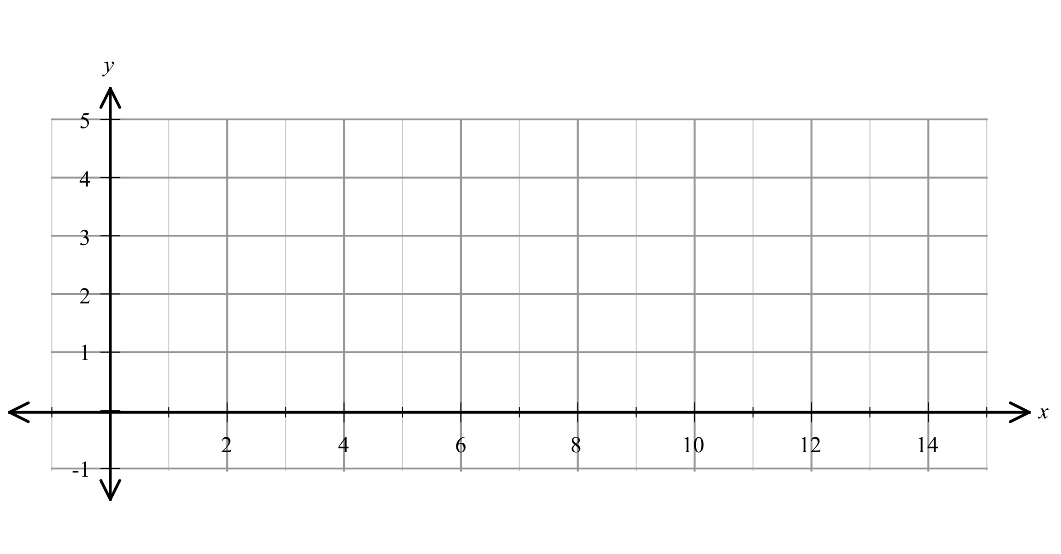f) Write three observations about the curve.

**2. Another way of looking at *e* [4, 2 marks]**

Another way of defining *e* is:



a) Complete the table below to get an approximate value for *e* correct to 5 decimal places.

Note : in maths n! (pronounced “n factorial” ) means



e.g. 5! = 5.4.3.2.1 = 120 (you can use your Classpad to do this)

|  |  |
| --- | --- |
| **n** | **Total (approximation for *e*)** |
| 1 |  |
| 2 |  |
| 3 |  |
| 4 |  |
| 5 |  |
| 6 |  |
| 7 |  |
| 8 |  |
| 9 |  |
| 10 |  |

b) Write this as a limit as n $→∞$

**3. Another limit………. [1, 4, 2 marks]**

Use your Classpad to create the graph of f(x) = ${(1+x)}^{\frac{1}{x}}$

1. You will notice that there is no value of f(x) when x = 0. Explain why.
2. You can approximate this value by approaching x = 0 and determining the approximate value. Complete this table to determine an approximation of the function when x = 0. Round to 5 decimal places.

Note: Use a graph created on the Classpad to do this!

|  |  |  |  |  |
| --- | --- | --- | --- | --- |
| x | f(x) |  | x | f(x) |
| 0.5 |  |  | -0.5 |  |
| 0.1 |  |  | -0.1 |  |
| 0.01 |  |  | -0.01 |  |
| 0.001 |  |  | -0.001 |  |
| 0.0001 |  |  | -0.0001 |  |
| 0.00001 |  |  | -0.00001 |  |

1. Remembering that we say that $\lim_{x→∞}{{\left(1+\frac{1}{x}\right)}^{x}}$ = e, write a definition of e based on the table above.

**4. An application of e [1, 2, 4 marks]**

Many bridges have arches that resemble a parabola but are not quite parabolic. This kind of shape is called a catenary curve. You can make a catenary curve by holding a piece of rope by both ends, one end in each hand, and let the rope swing freely. One model for a catenary curve is

f(x) = $\frac{a}{2}(e^{\frac{x}{a}}+ e^{-\frac{x}{a}}$) where *a* is a real, non-zero constant.

1. Let a = 2. Write the equation of the curve.

b) Plot this equation on your Classpad and sketch below.

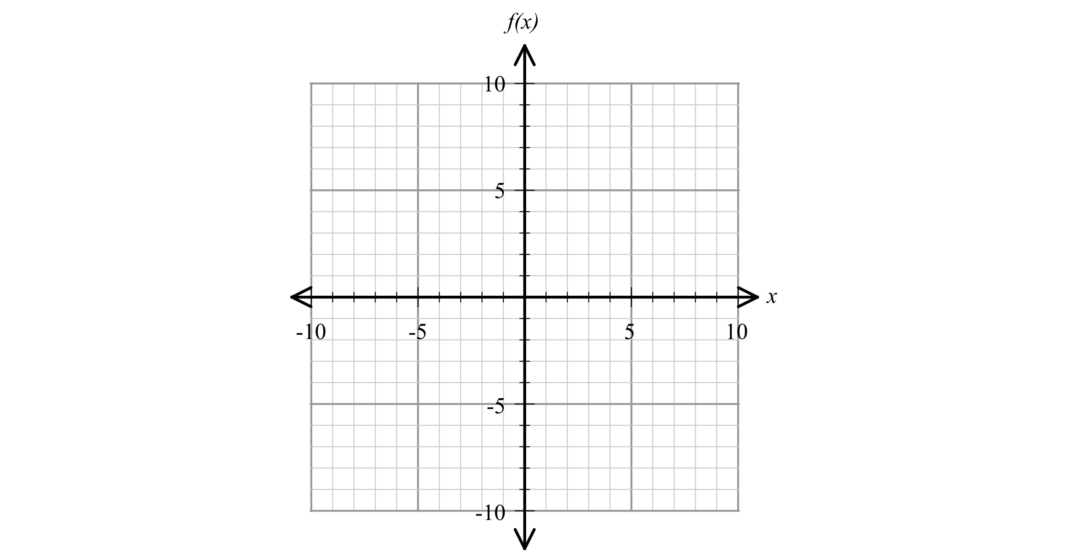

c) Determine the function g(x), which is parabolic and approximates this curve. Working is required here, and you should describe what you did to find this function.

**5. Another application. [4, 2, 1 marks]**

When compound interest is determined we would use A = P(1 + r)n, where A is the amount returned after the time period, P is the Principal, r is the rate as a decimal and n is the number of times that interest is credited.

Assume $100 is invested at 10% pa interest credited annually,

After 1 year the A = $110

If the interest is credited quarterly this will be

A = 100(1 + )4 = $110.38

We divide the rate by 4 as it is now quarterly and raise this to the power of 4 because interest is credited 4 times.

1. Determine what A would be if interest was credited monthly and daily.
2. If interest was calculated continuously, what would A be? Explain your reasoning.

c) What is the value of A if it was written in terms of e?